

**Project Status Report**



**Project Name:** Barcode Info

**Department:** Operation and Maintenance Department

**Focus Area:** Weather Stations

**Product/Process:** Preventive Maintenance of Weather Stations



**Prepared By:**

|  |  |
| --- | --- |
| **Document Owner(s)** | **Project/Organization Role** |
| Miguel Mayor | Project Manager |
| Joanna De Guzman | Project Editor |
| Adrian Tobias | Project Researcher |

**Project Status Report Version Control**

|  |  |  |  |  |
| --- | --- | --- | --- | --- |
| **Version** | **Date** | **Author** | **Change Description** | |
| 1.0 | 04/13/16 | Miguel Mayor | Document created | |
| 1.1 | 04/20/16 | Miguel Mayor | * Statement of the Problem was more specific * Solutions that were in the paper was removed * Paper was modified in a way that it expands what data is used and it focused more on the problem | |
| 1.2 | 07/04/16 | Adrian Tobias | * Context, Use Case, and Data flow has been updated * Timing, State, Class, Use Case Fully Development * Paper has be revised to a theoretical view | |
| 1.3 | 07/10/16 | Adrian Tobias | * Sequence, Activity, Communication Diagram has been created * Other diagrams are updated according to the noted revisions | |
| 1.4 | 07/17/16 | Adrian Tobias | * Change paper according to Computer Science with Software Development format * Project Context added, Purpose and Definition updated, Design and Methodology is added | |
| 1.5 | 07/24/16 | Adrian Tobias | * Package Diagram and Composite Diagram Added | |
| 1.6 | 08/06/16 | Joanna De Guzman | * Component Diagram and Deployment Diagram Added | |
| 1.7 | 08/15/16 | Joanna De Guzman | * Content Added | |
| 1.8 | 08/20/16 | Joanna De Guzman | * Forms to be printed and submitted has been completed | |
| 1.9 | 09/21/16 | Adrian Tobias | * Clients request and needs are recorded | |
| 2.0 | 10/03/16 | Adrian Tobias | * Forms has been signed and updated | |
| 2.1 | 10/09/16 | Joanna De Guzman | * Web Application has been updated | |
|  | | | |

**TABLE OF CONTENTS**

1 PROJECT STATUS REPORT PURPOSE 3

2 PROJECT STATUS REPORT TEMPLATE 3

2.1 Project Status Report Details 3

2.2 Project Status Report Template 3

3 PROJECT STATUS REPORT APPROVALS 3

4 APPENDICES 3

4.1 Document Guidelines 3

4.2 Project Status Report Sections Omitted 3

# PROJECT STATUS REPORT PURPOSE

The Project Status Report is a document that Project Managers may use as a means of formal regular reporting on the status of a project to key project stakeholders, including the Steering Committee, Project Sponsor, and Senior Manager.



# PROJECT STATUS REPORT TEMPLATE

## Project Status Report Details

* [Status of the Project]
  + Project Barcode Info plans to design an improved system for the Operations and Maintenance of weather.com.ph by using a modern software solution that will provide faster results and convenience compared to the older system.
  + Milestone Deliverable/s: Updated web application

* [Budget Report]
  + Food and Beverages – ₱ 325
  + Transportation - ₱ 225

* [Risk Management Report—Specify any changes to the major risks identified since the previous report and modification to the strategies put in place to manage them, if appropriate.]
  + Web Application is needed to be reviewed by Project Advisor

* [Issues Report]
  + Feedback is needed for the web application design and functionality
* (Recommendations) Present to project advisor so that feedback could be establish among the group

## Project Status Report Template

|  |  |  |
| --- | --- | --- |
| Barcode Info | | |
| Prepared By:  Adrian Tobias | Date:  10/03/16 | Reporting Period:  10/07/16 to 10/09/16 |
| Project Overall Status:   * Project is ready to be presented. | | |
| Project Summary:   * Project will be presented to the client for feedback | | |
| **Milestone Deliverables performance reporting over last period**   |  |  |  |  | | --- | --- | --- | --- | | **Milestone Deliverables** | **Due Date** | **% Completed** | **Deliverable Status** | | Milestone 1 | | | | | * Project Forms | 10/08/16 | 90% | On Schedule | |  |  |  | On Schedule | |  |  |  | On Schedule | | Milestone 2 | | | | |  |  |  | On Schedule | |  |  |  | On Schedule | |  |  |  |  | | | |
| **Milestone Deliverables scheduled for completion over next period**   |  |  |  |  | | --- | --- | --- | --- | | **Milestone Deliverables** | **Due Date** | **% Completed** | **Deliverable Status** | | Milestone 1 | | | | | * Main Paper (Business) | 10/09/16 | 0% | On Schedule | |  |  | 0% | On Schedule | | Milestone 2 | | | | | | |
| **Project impact of milestone success or failure for project remainder**   |  |  | | --- | --- | | With the paper created for the project, it will tackle the business benefits of implementing such web application | Comments and feedbacks are important so that the project will progress by preventing future errors | | | |
| **Project** **Budget/Financial Status**   |  |  |  |  | | --- | --- | --- | --- | | **Budget Item** | **Planned Budget** | **Actual Cost** | **Variance/Explanation** | | Food and Beverages | 1000 | 425 | Food and Beverages consumed | | | |
| **Project Risk Management Status**   |  |  |  |  |  | | --- | --- | --- | --- | --- | | **Risk and Description** | **Risk Chance** | **Risk Impact** | **Risk Priority** | **Change from Last Review** | | Will the new system improved the old system? | Medium | High | High | Some of the functionalities have been finish | | | |
| **Project Issue Management Status**   |  |  |  |  |  | | --- | --- | --- | --- | --- | | **Issue and Description** | **Project Impact** | **Target Due Date** | **Issue Status** | **Issue Resolution** | | Presentation to the Project Advisor | High | 10/04/16 | Open | Project to be presented to the client for feedback | | | |
| **Project Recommendations**   |  | | --- | | * Will the project deliverables be completed within acceptable quality levels?   The deliverables will be submitted before their deadlines. The new requirements will be checked and verified by our Advisor   * Are project issues and risks being addressed successfully and mitigated?   Yes, they are handled and the creation of the solution for these problems are being done with the highest priority | |  | | | |
| **Objectives for Next Project Status Review**   |  | | --- | | * To record the feedback and the comments from the client * To update the project even further according to the comments of the client | | | |
| **Related Project Information**   |  | | --- | |  | | | |

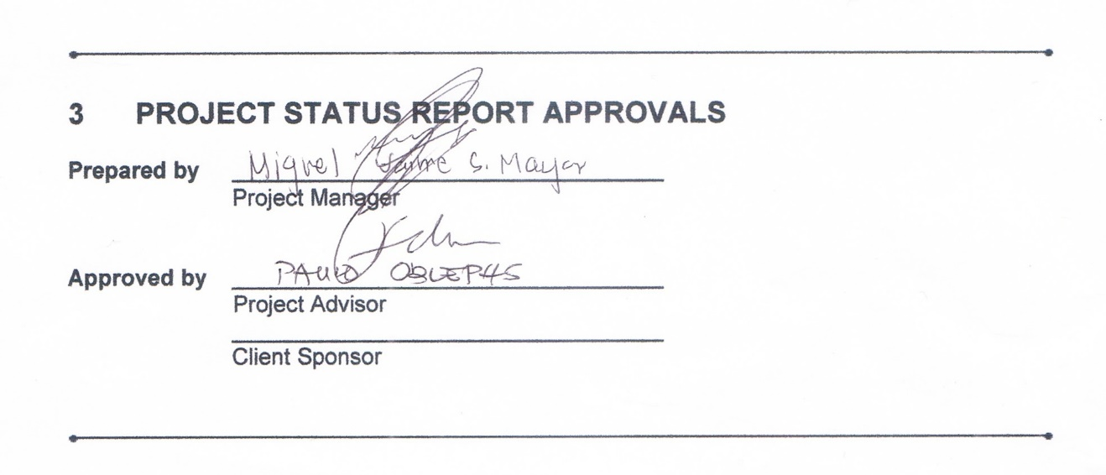

# APPENDICES

## Document Guidelines

## Project Status Report Sections Omitted

